What is Indexing? How does Indexing work?
A Database Index is a data structure that helps retrieve data quickly from a database table. It improves search speed but requires extra storage space and makes insert, update, and delete operations slightly slower.
Book Example:
An index in a database works like the index at the back of a textbook. Instead of reading the whole book, we find the topic in the index and directly go to the required page.
How does Indexing work
Indexing works like the index of a book. Instead of searching every page, we first look at the index, find the page number, and then directly go to the required page.
Similarly, in a database, an index stores search-key values and pointers to the corresponding records. When a user searches for data, the database first searches the index and then directly accesses the required record. This reduces the number of records that need to be scanned and makes data retrieval much faster.
- What is Primary, Secondary Index and Multilevel Index? Difference between Primary, Secondary Index and Multilevel Index?
Primary Index:
Primary Index is an index in which the data file is organized (sorted) according to the search key.
Example:
In the Dense Index and Sparse Index figures, records are stored in alphabetical order of branch names (Brighton, Downtown, Mianus, Perryridge, Redwood, Round Hill). Therefore, the index on branch name is a Primary Index.
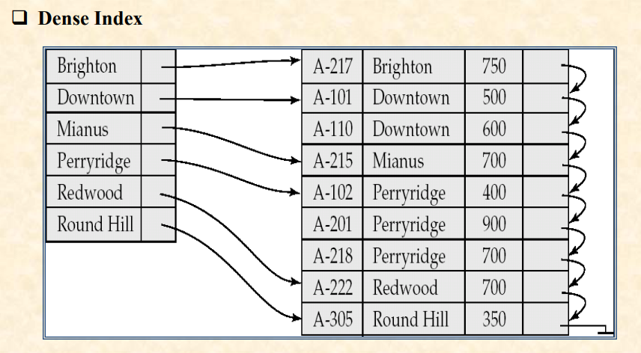
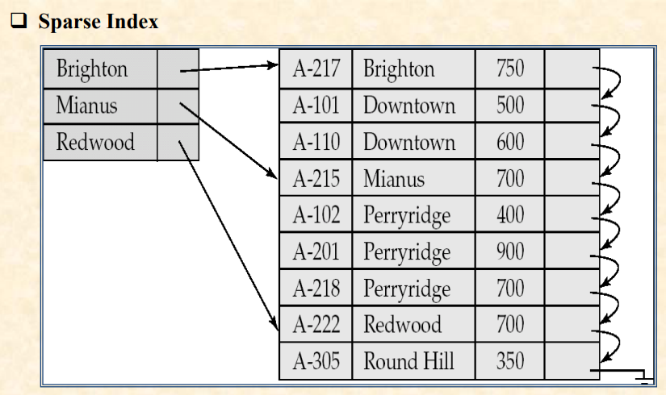

Secondary Index
A Secondary Index is an index whose search key does not determine the physical order of records.

Figure Example
In the Secondary Index figure, records are stored by branch name, but the index is created on balance values (350, 400, 500, 600, 700, 750, 900).
So the balance field creates a Secondary Index.

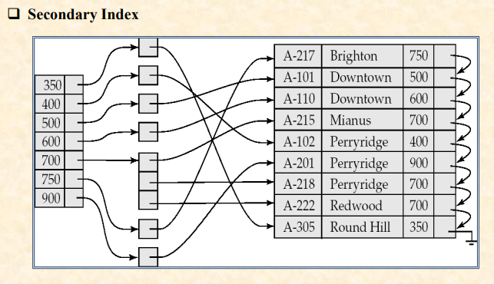
Multilevel Index:
When an index becomes very large, another index is created on that index. This is called a Multilevel Index.

Figure Example
In the Multilevel Index figure:
- Outer Index → points to Inner Index
- Inner Index → points to Data Blocks
So searching becomes:
Outer Index → Inner Index → Data Record
which is much faster.
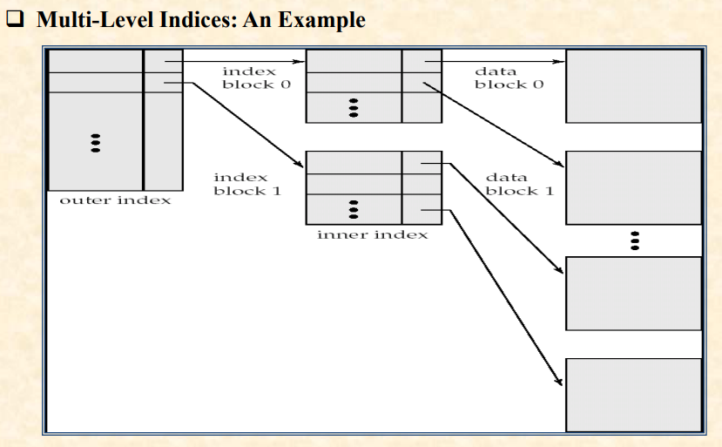
Difference Between Primary, Secondary and Multilevel Index:
Feature | Primary Index | Secondary Index | Multilevel Index
Definition | Index based on the field by which records are physically stored | Index based on a field that does not determine the physical order of records | An index created on another index
File Ordering | Data file is sorted by the search key | Data file is not sorted by the search key | Works on multiple levels of indices
Purpose | Fast access to ordered records | Provides an additional access path | Improves search efficiency for very large indices
Number per File | Usually one | Multiple can exist | Multiple levels can exist
Storage Space | Less | More | More than Primary and Secondary
Search Speed | Fast | Fast, but slower than Primary | Fastest for very large files
Example | Records stored by Student ID and indexed on Student ID | Records stored by Student ID but indexed on Student Name | Outer Index → Inner Index → Data Record

- What is Dense and Sparse index? Difference between them?

Dense Index

A Dense Index contains an index entry for every search-key value in the data file.

Based on the Figure
In the Dense Index figure, every branch name has an index entry:
- Brighton
- Downtown
- Mianus
- Perryridge
- Redwood
- Round Hill
Each entry directly points to the corresponding record.

Easy Bangla
Dense Index-এ Data File-এর প্রতিটি Search Key-এর জন্য Index Entry থাকে।
ছবিতে দেখা যাচ্ছে প্রতিটি Branch Name-এর জন্য আলাদা Entry আছে, তাই এটি Dense Index।
👉 Every Record = One Index Entry


Sparse Index
A Sparse Index contains index entries for only some search-key values.

Based on the Figure
In the Sparse Index figure, only:
- Brighton
- Mianus
- Redwood
have index entries.
Downtown, Perryridge, and Round Hill-এর জন্য কোনো Entry নেই।
প্রথমে কাছের Entry খুঁজে বের করতে হয়, তারপর Data File scan করে কাঙ্ক্ষিত Record পাওয়া যায়।

Easy Bangla
Sparse Index-এ সব Search Key-এর জন্য Entry থাকে না, শুধুমাত্র কিছু Key-এর জন্য Entry থাকে।
ছবিতে শুধু Brighton, Mianus এবং Redwood আছে।
👉 Some Records = Some Index Entries


Difference Between Dense and Sparse Index
Dense Index | Sparse Index
Index entry for every search key | Index entry for only some search keys
Faster searching | Slower searching
More storage space required | Less storage space required
More maintenance needed | Less maintenance needed
Directly points to the record | May need additional searching in data file

- Types of Indices? Discuss Evaluation Factors?

Types of Indices
There are two basic types of indices:

1. Ordered Index
Definition:
An Ordered Index stores the values of the search keys in sorted order.
Features:
- Records are arranged according to the search key.
- Provides fast access to records.
- Each index is associated with a specific search key.
- A file may have multiple ordered indices.
Easy Bangla:
Ordered Index-এ Search Key গুলো সাজানো (Sorted) অবস্থায় থাকে। তাই Data দ্রুত খুঁজে পাওয়া যায়।
Example: Primary Index, Secondary Index, Dense Index, Sparse Index.

2. Hash Index
Definition:
A Hash Index uses a Hash Function to distribute records into different buckets.
Features:
- Data is stored in buckets.
- The bucket is determined by a hash function.
- Very fast for exact searches.
Easy Bangla:
Hash Index-এ Hash Function ব্যবহার করে Data বিভিন্ন Bucket-এ রাখা হয়। ফলে দ্রুত Data খুঁজে পাওয়া যায়।

Search Key

Definition
A Search Key is an attribute or set of attributes used to locate records in a file.

Example
- Student ID
- Account Number
- Employee ID

Easy Bangla
যে Attribute বা Attribute-এর সমষ্টি ব্যবহার করে Record খুঁজে পাওয়া যায় তাকে Search Key বলে।

Evaluation Factors of Indexing
কোন Indexing Technique ভালো হবে তা নিচের বিষয়গুলোর উপর নির্ভর করে।

1. Access Type

Definition
The type of search operation supported by the index.

Example
- Finding a specific record
- Finding records within a range

Easy Bangla
Index কোন ধরনের Search Support করে তা বোঝায়।

2. Access Time

Definition
The time required to find a particular record.

Easy Bangla
ডেটা খুঁজে পেতে কত সময় লাগে।
👉 কম সময় = ভালো Performance

3. Insertion Time

Definition
The time required to insert a new record and update the index.

Easy Bangla
নতুন Record Insert এবং Index Update করতে যত সময় লাগে।

4. Deletion Time

Definition
The time required to delete a record and update the index.

Easy Bangla
Record Delete এবং Index Update করতে যত সময় লাগে।

5. Space Overhead

Definition
The extra storage space required by the index structure.

Easy Bangla
Index সংরক্ষণের জন্য অতিরিক্ত কত Storage লাগে।
👉 বেশি Space লাগলেও যদি Search দ্রুত হয়, তাহলে তা গ্রহণযোগ্য।

Difference Between Ordered Index and Hash Index
Ordered Index | Hash Index
Stores keys in sorted order | Uses hash function
Good for range search | Good for exact search
Data is ordered | Data is stored in buckets
Comparatively slower | Very fast

- What is Index and Hashing? Difference between them?

Index
An Index is a data structure that helps retrieve records quickly from a database table.
It stores search-key values along with pointers to the corresponding records.

Easy Bangla
Index হলো এমন একটি Data Structure যা Database থেকে দ্রুত Data খুঁজে পেতে সাহায্য করে।
এটি Search Key এবং Record-এর Pointer সংরক্ষণ করে।
Example:
বইয়ের শেষে থাকা Index দেখে দ্রুত নির্দিষ্ট পৃষ্ঠা খুঁজে পাওয়ার মতো।

Hashing
Hashing is a technique that uses a Hash Function to map a search-key value to a specific bucket where the record is stored.

Easy Bangla
Hashing হলো এমন একটি পদ্ধতি যেখানে Hash Function ব্যবহার করে Data-কে নির্দিষ্ট Bucket-এ সংরক্ষণ করা হয়।
ফলে খুব দ্রুত Data খুঁজে পাওয়া যায়।
Example:
Student ID → Hash Function → Bucket → Record

Difference Between Index and Hashing
Index | Hashing
Uses an index structure | Uses a hash function
Search keys are often stored in sorted order | Data stored in buckets
Supports exact search and range search | Best for exact search
Slower than hashing for exact match | Very fast for exact match
Suitable for ordered data | Suitable for direct access

- What is B+ tree / B tree?
A B+ Tree is a balanced multilevel index structure used in databases for fast searching, insertion, and deletion of records.
In a B+ Tree, all actual data records are stored in the leaf nodes, while non-leaf nodes contain only search keys and pointers.

Easy Bangla
B+ Tree হলো একটি Balanced Multilevel Index Structure যা Database-এ দ্রুত Search, Insert এবং Delete করার জন্য ব্যবহৃত হয়।
এখানে সব Data Record Leaf Node-এ থাকে, আর Non-Leaf Node-এ শুধু Search Key ও Pointer থাকে।

Key Features
- Balanced Tree
- All leaf nodes are at the same level
- Supports fast searching
- Widely used in DBMS
Example:
ধরো একটি Bank Database-এ Account Number অনুযায়ী তথ্য সংরক্ষণ করা আছে:
1001, 1005, 1010, 1015, 1020, 1025, 1030, 1035
B+ Tree দেখতে এমন হতে পারে:
[1015 | 1025]
/ | \
[1001,1005,1010] [1015,1020] [1025,1030,1035]
(Leaf Node) (Leaf Node) (Leaf Node)

কী হচ্ছে এখানে?
- Root Node (Non-Leaf) = [1015 | 1025]
  - এখানে শুধু Search Key আছে।
  - Actual Data নেই।
- Leaf Nodes
  - সব Account Number এখানে সংরক্ষিত।
  - অর্থাৎ Actual Records Leaf Node-এ থাকে।

Search Example
ধরো Account Number 1030 খুঁজতে হবে।
Step 1: Root Node দেখো
[1015 | 1025]
1030 > 1025
তাই ডান পাশের Pointer Follow করব।
Step 2: ডান পাশের Leaf Node-এ যাব
[1025,1030,1035]
এখানে 1030 পাওয়া গেল।
✅ খুব দ্রুত Search সম্পন্ন হলো।

Explain node structure of B+ tree / B tree?

Node structure of a B+ Tree Node
According to your slide:
A node contains:
- Search Keys (K₁, K₂, K₃ ...)
- Pointers (P₁, P₂, P₃ ...)

Example
P1 | K1 | P2 | K2 | P3 | K3 | P4

Rules

Non-Leaf Node
- Contains only keys and pointers
- Maximum = n pointers
- Minimum = ⌈n/2⌉ pointers

Leaf Node
- Contains actual data records
- Maximum = n−1 keys
- Minimum = ⌈(n−1)/2⌉ keys

Root Node
- If root is not leaf:
  - Minimum 2 children
- If root is leaf:
  - Can contain 0 to n−1 values

Fanout
The number of pointers in a node is called Fanout.
Example:
P1 K1 P2 K2 P3 K3 P4
There are 4 pointers.
➡️ Fanout = 4

Easy Bangla Answer
B+ Tree-এর প্রতিটি Node-এ:
- Search Key থাকে
- Pointer থাকে

Non-Leaf Node
শুধু Key ও Pointer রাখে।

Leaf Node
আসল Data Record রাখে।

Fanout
Node-এ যতগুলো Pointer থাকে তাকে Fanout বলে।

Exam Answer (5 Marks)
A B+ Tree node contains search-key values and pointers. Non-leaf nodes contain only keys and pointers, while leaf nodes contain actual records. A non-leaf node can have up to n pointers and at least ⌈n/2⌉ pointers. The number of pointers in a node is called fanout. All leaf nodes are maintained at the same

- Create a B+ tree for order 10

Meaning of Order 10
Order = 10 means:
- Maximum children = 10
- Maximum keys = 9
Because:
Maximum Keys = Order - 1
= 10 - 1
= 9

Example B+ Tree (Order 10)
[30 | 60]
/ | \
[5 10 15 20] [35 40 50] [65 70 80 90]

Verification
Root Node:
- Keys = 2
- Children = 3
Leaf Nodes:
- Keys are less than or equal to 9 ✔
All leaf nodes are at the same level ✔
Therefore it is a valid B+ Tree of order 10.
Just mone rakhar jonno:
Keys joto hobe pointer tar cheye 1 beshi hobe. Here, Keys: [30 | 60]. Ekhane Pointer line: 3ta.
Abar order joto hobe keys er keys er number max tar cheye 1 kom hobe.
Ekhane:
Maximum Keys = Order - 1
= 10 - 1
= 9

2. Search Key

English
A Search Key is an attribute or set of attributes used to find records in a file.
Example:
Student ID, Account Number, Employee ID.

Bangla
যে Attribute বা Attributes-এর সাহায্যে রেকর্ড খুঁজে পাওয়া যায় তাকে Search Key বলে।
উদাহরণ:
Student ID, Account Number, Employee ID।

3. Types of Indices
There are two main types of indices:

1. Ordered Index

2. Hash Index

Ordered Index

English
An Ordered Index stores search-key values in sorted order.

Bangla
Ordered Index-এ Search Key গুলো সাজানো (Sorted) অবস্থায় সংরক্ষিত থাকে।

Hash Index

English
A Hash Index uses a hash function to distribute records into buckets.

Bangla
Hash Index একটি Hash Function ব্যবহার করে ডেটাকে বিভিন্ন Bucket-এ সংরক্ষণ করে।

Easy Comparison
Ordered Index | Hash Index
Data stored in sorted order | Data stored using hash function
Good for range search | Good for exact search
Slower than hash for exact search | Very fast for exact search

